Personal Development
Semester 6: Advanced Technology
Fontys University of Applied Science
Eindhoven, The Netherlands

Date : 19.01.2023
Version : 1.0
Status : Final Version
Author : Casey Stijlaart

Table of Contents
1 Persona 4
2 Context 5
3 Project 6
3.1 Top 3 Projects 6
3.3 Personal Project 6
4 Learning outcome table with proof 7
4.1 Products with their description 7
4.1.1 Project Management - Git 7
4.1.2 Project Plan 7
4.1.3 Database Research 7
4.1.4 Algorithm Research 7
4.1.5 Test Application 7
4.1.6 System Design Document 7
4.1.7 Test Plan 7
4.1.8 Code Examples 7
4.1.9 Message Protocol 7
4.1.10 Generation of Musical Composition 7
4.1.11 Project Configuration 8
4.1.12 Project Report 8
4.1 Learning Outcome Table 9
5 Sprint retrospective and personal reflection 12
5.1 Sprint 1 12
5.1.1 Retrospective 12
5.1.2 Reflection 12
5.2 Sprint 2 13
5.2.1 Retrospective 13
5.2.2 Reflection 13
5.3 Sprint 3 14
5.3.1 Retrospective 14
5.3.2 Reflection 14
5.4 Sprint 4 15
5.4.1 Retrospective 15
5.4.2 Reflection 15
5.5 Sprint 5 16
6 Evaluation and reflection on the whole semester 17
7 Feedpulse 18

Persona
Name: Casey Stijlaart (He/Him)
Age: 23
Personality Type: ISTJ-A

Photograph:


Background:
In addition to my specialization in technology and embedded systems, I have also delved into various aspects of ICT through coursework and practical projects. This well-rounded education has equipped me with an understanding of various programming languages, including C, C++, and Python, as well as expertise in software design. Furthermore, my studies, including my internship, have helped me refine my overall skills in software development and how to adapt to new situations, regarding the project I am working on.

Interests:
Beyond my education, I find comfort and inspiration in a variety of ways, each provided my interests. One of my main interests is thinking about new approaches and how to challenge current challenges within our society. How one can help improve the current situation, or how one can make the life of another individual easier. Looking at more practical things that keep me busy during my time off.
Different things bring me peace, such as being surrounded by nature, gaming, and having a creative outlet.

Skills:
  - Communication: I value effective communication, both written and verbal. I have experience collaborating on group projects, presenting ideas, and conveying complex technical concepts in an accessible manner.
  - Critical Thinking: My educational journey has enhanced my critical thinking skills, enabling me to analyze problems from multiple perspectives and devise innovative solutions.
  - Teamwork: Collaborative projects have taught me the importance of teamwork and cooperation. I'm adept at working in diverse groups and leveraging the strengths of each team member to achieve common goals.

Context
One of the contexts that deeply resonates with me is the usage of technology in healthcare. My personal experiences as someone who relies on various aspects of healthcare have made me aware of the importance of improving the current state of healthcare, and I believe that technology plays an important role in achieving this.

My motivation to work in this context is twofold. Firstly, I am driven by the desire to contribute to the betterment of healthcare systems, particularly in enhancing patient outcomes and experiences. For instance, the integration of robotics in surgeries presents an exciting opportunity to decrease surgical risks and improve overall results. This not only captivates my interest but also aligns with my belief that technology can be harnessed to save lives and improve the quality of care.
In essence, my drive stems from a deep-seated belief in the transformative potential of technology in healthcare. I aspire to actively contribute to this field, improving the lives of individuals and helping shape the future of healthcare through innovation and responsible technological integration.

Project

Top 3 Projects
    - (IoT) measurement setup for observing lab set-ups
This project holds significant appeal for me due to its potential to enhance scientific research and experimentation. The integration of IoT technologies in lab environments not only enables real-time data collection but also can improve efficiency.
    - Autonomous exploration of a building
The concept of autonomous systems navigating and interacting with their environment is at the forefront of technological advancement. This project presents an exciting opportunity to delve into how the way of exploration can be improved and made safer for any involved party.
    - Autonomous Guided Vehicle Platform
The prospect of developing AGV platform sparks my interest as it gives the opportunity to challenge the capabilities of an AGV system. How the system can efficiently navigate and interact with diverse environments.

  - Assigned Research Project: (IoT) measurement setup for observing lab set-ups For the group project I got assigned the (IoT) measurements setup for observing lab set-ups. The task is to create a prototype for an measurement setup. The measurement setup focuses on measuring different aspects of a lab setup, storing the data, and allowing groups to access the data. The group, that requested the data, should only have access to their data.
Looking at my personal goals for leaning throughout this project, the focus will be on the following aspects :
- Project Management : As I have been always been in the background when working on projects, I would like to step up more. Getting more of a feel for how to handle and manage a group project. Pushing me to be more communicative and take a different approach when things aren’t going as planned.
- Safety and Security: In prior projects, the focus was never on creating a system that takes security into account. Therefore I want to focus more on this aspect while working on this project, as within this project security is a more important aspect to be covered.

Personal Project
For the personal project, a system is created that takes environmental data, such as temperature and sound levels, and creates musical output with the help of algorithms and IoT connectivity.
With the help of this project, I want to broaden my horizons with aspects I am unfamiliar with. For example, using algorithms to create an output based on data. Introducing new tools will allow me to get more comfortable with approaching and tackling problems I have not dealt with prior.
Another personal of learning is to be more research-based, as prior projects usually already had a direction given. Certain rules and requirements were already set, and therefore only specific research
had to be made. With this project, I would like to do more research on the possibilities out there and which is the most suitable.

Learning outcome table with proof

Products with their description

Project Management - Git
Description: A comprehensive project plan for the personal project, including problem analysis, objectives, timeline, and risk management.
Name in Canvas: PP+GP-project-management.pdf , PP+GP-git-pipeline.pdf

Project Plan
Description: A comprehensive project plan for the personal project, including problem analysis, objectives, timeline, and risk management.
Name in Canvas: PP-project-plan.pdf, GP-project-plan.pdf

Database Research
Description: Research on database storage options, data structure techniques, and recommendations for your group project.
Name in Canvas: GP-research-database.pdf

Algorithm Research
Description: Research on various algorithms for generating music based on environmental data. Name in Canvas: PP-research-algorithms.pdf

Test Application
Description: A test application for evaluating the various functionalities of the two projects.
Name in Canvas: PP-Test-App-Database.png , PP-Test-App-Database.png , GP-test-application-automated-connection.mp4 , GP-Application-Database-Access-Control.mp4, GP-Dashboard-Experiment-Control.mp4, PP-Musical-Composition-Control.mp4

System Design Document
Description: Two comprehensive system design documents. In which various system architecture, design, and behavior are discussed.
Name in Canvas: PP-system-design-document.pdf , GP-system-design-document.pdf

Test Plan
Description: A comprehensive document, which discusses how the project will be tested.
Name in Canvas: PP-test-plan.pdf

Code Examples
Description: A comprehensive document, which showcases various code implementations.
Name in Canvas: GP-Code-Examples.pdf

Message Protocol
Description: A comprehensive document, which discusses the message structure and message types, that can occur within the IoT data lab group project.
Name in Canvas: GP-Message-Protocol.pdf

Generation of Musical Composition
Description: A test application for evaluating the generation of musical composition, with a focus on the requirements.
Name in Canvas: PP-Output-CustomComposition-Poor.mp3, PP-Output-CustomComposition-Good.mp3

Project Configuration
Description: This detailed document delves into how the project is structured, how it is managed and the system parts are build.
Name in Canvas: GP-project-configuration.pdf

Project Report
Description: A detailed document that presents the project's results, drawing conclusions and offering recommendations based on the outcomes.
Name in Canvas: GP-project-report.pdf, PP-project-report.pdf

Learning Outcome Table
Learning outcome | Proof | Rating
LO1: Analysis  You specify a distributed computer system including timing, resource use and performance, taking into account safety aspects. And you compile an acceptance test plan and an integration  test plan | Product: Database Research: GP- research-database.pdf  Product: Test Application: PP- Test-App-Database.png , PP-Test-App- Database.png  Product: System Design Document: PP- system-design-document.pdf  Product: System Design Document: GP- system-design-document.pdf  Product: Test Plan: PP-test-plan.pdf | Current: Proficient Self:
LO2: Advise  Based on your analysis, you provide technical advisory on the (distributed) computer system that is to be realized, including hardware and  software components and links. | Product: Algorithm Research: PP- research-algorithms.pdf  Product: Database Research: GP- research-database.pdf  Product: System Design Document: PP- system-design-document.pdf  Product: System Design Document: GP- system-design-document.pdf  Product: Message Protocol: GP-Message-Protocol.pdf  Product: Project Report : GP-project-report.pdf, PP-project-report.pdf | Current: Proficient Self:
LO3: Design  You design a distributed computer system including determining actuators, sensors, timing, resource  usage, and performance. | Product: Database Research: GP- research-database.pdf  Product: System Design Document: PP- system-design-document.pdf  Product: System Design Document: GP-  system-design-document.pdf  Product: Message Protocol: GP-Message-Protocol.pdf  Product: Project Configuration : GP-project- configuration.pdf | Current: Proficient  Self:
LO4: Realisation  You realize a complete computer system (or parts thereof) including network, hardware, and system software based on your own design. And you compile and carry out an acceptance procedure to validate the  implementation. | Product: Test Application: PP- Test-App-Database.png, PP-Test-App- Database.png  Product: Test Plan: PP-test-plan.pdf  Product: Test Application: GP-test-application-automated-connection.mp4  Product: Generation of Musical Composition:PP-Output-CustomComposition-Poor.mp3, PP-Output-CustomComposition -Good.mp3  Product: Test Application: GP-Application-Database-Access-Control.mp4  Product: Test Application: GP-test-application-automated-connection.mp4  Product: Project Configuration : GP-project- configuration.pdf  Product: Test Application: PP-Musical-Composition-Control.mp4 | Current: Proficient Self:
LO5: Manage & Control  You set up and make use of a system for version management, release management, teamwork support, and automated testing for hard- and software  systems. | Product: Project Management - Git: PP+GP-project-management.pdf Product: Project Management - Git: PP+GP-git-pipeline.pdf  Product: Test plan: PP-test-plan.pdf  Product: Project Configuration : GP-project- configuration.pdf | Current: Proficient  Self:
LO6: Future-oriented organisation  You explore the organizational context of ICT assignments, make business, sustainable, and ethical considerations, and manage all aspects of the  execution of the assignment. | Product: Database Research: GP- research-database.pdf  Product: System Design Document: PP- system-design-document.pdf  Product: System Design Document: GP- system-design-document.pdf  Product: Code Examples: GP-Code-Examples.pdf  Product: Project Configuration: GP-project- configuration.pdf | Current: Proficient Self:
LO7: Investigative problem solving  You critically consider IT assignments from different perspectives, identify problems, find an effective approach and come up with appropriate solutions. | Product: Algorithm Research: PP- research-algorithms.pdf  Product: Database Research: GP- research-database.pdf  Product: Code Examples: GP-Code-Examples.pdf  Product: Project Report: GP-project-report.pdf, PP-project-report.pdf | Current: Proficient Self:
LO8: Personal Leadership  You are entrepreneurial with regard to ICT assignments and personal development, pay attention to your own learning ability, and keep in mind what kind of ICT professional and/or what type of positions you  aspire to. | Product: Project Plan: PP-project- plan.pdf  Product: Personal Development: personal-development-document.pdf | Current: Proficient  Self:
LO9: Targeted Interaction You determine which partners play a role in the ICT assignment, collaborate constructively with them, and communicate appropriately to  achieve the desired impact. | Product: Project Plan: PP-project- plan.pdf  Product: Project Management - Git: PP+GP-project-management.pdf  Product: Project Configuration: GP-project- configuration.pdf  Product: Project Report: GP-project-report.pdf, PP-project-report.pdf | Current: Proficient Self:

Sprint retrospective and personal reflection

Sprint 1
While being ill for a long period of time during this sprint, some conclusions can be made regarding the retrospective and reflection.

Retrospective
What went well:
- After some struggles, the team for the group project came back together as a team and became more communicative.
Areas for improvement:
- As I have been sick for a while, I could improve in being more communicative on the situation and what can be expected of me, towards the team and myself.
Action items:
- Improve planning : I want to create a clear board of tasks to help with an easier way of planning what the current goal is and what is next. Ensuring there is always something to do.

Reflection
What went well:
- While there were struggles in the beginning with communication and a clear direction, I took it upon myself to be a guide as there was no clear “lead” in the group itself. This does resonate with my personal goal of project management, as I have been pushed to broaden my horizon on how we could make this project head in a better direction.
- Within the projects I have been more focused on what is out there instead of the things I know and am more comfortable with. Meaning that I have been more focused on researching possibilities instead of going with what I know.
Areas for improvement:
- While I have been focused on taking a more research-based approach, I still tend to be held back due to wanting to do what I know.
Action items :
- Explore the options on how to help improve project management.

Sprint 2

Retrospective
What went well:
- After some struggles, the team for the group project came back together as a team and became more communicative.
Areas for improvement:
- As I have been sick for a while, I could improve in being more communicative on the situation and what can be expected of me, towards the team and myself.
Action items:
- Improve planning : I want to create a clear board of tasks to help with an easier way of planning what the current goal is and what is next. Ensuring there is always something to do.

Reflection
What went well:
- While there were struggles in the beginning with communication and a clear direction, I took it upon myself to be a guide as there was no clear “lead” in the group itself. This does resonate with my personal goal of project management, as I have been pushed to broaden my horizon on how we could make this project head in a better direction.
- Within the projects I have been more focused on what is out there instead of the things I know and am more comfortable with. Meaning that I have been more focused on researching possibilities instead of going with what I know.
Areas for improvement:
- While I have been focused on taking a more research-based approach, I still tend to be held back due to wanting to do what I know.
Action items :
- Explore the options on how to help improve project management.

Sprint 3

Retrospective
What went well:
- After struggles with people showing up to college, we had an open conversation about the situation. Which really helped the team to come closer together and get a better understanding of each perspective.
Areas for improvement:
- While some of the team members are active with committing and keeping an eye on open merge requests, the others seem to not be consistent. Especially when it comes to the merge requests, as sometimes it takes days to be reviewed or updated based upon reviews.
Action items:
- Improve pipeline for automated testing, for example, setup a server, so the pipeline runner does not depend on whether the runner on my laptop is up and running.

Reflection
What went well:
- Overall communicated well with the team, and tried to explain where I could, and when necessary.
Areas for improvement:
- As I sometimes have the tendency take the lead too much, I could step down sometimes to ensure other feel the space too discuss their point of view. I do try to ask how they see it, etc., but I forget occasionally.
Action items :
- Focus more on what can be achieved and is feasible, and less on what could be achieved if there was more time.

Sprint 4

Retrospective
What went well:
- Been more active on meeting at campus, which boosted the productivity and overall way of working. Especially as the different parts had to start coming together.
Areas for improvement:
- When problems arise, don’t get stuck on it too long. Find a different approach as too much time gets lost by trying to fix it.
Action items:
- Last demo demonstrate the whole process and little technical detail.

Reflection
What went well:
- Been able to be more at campus, and been more aware of what is going on within the team.
Areas for improvement:
- While wanting to help everyone when they need it, occasionally I should prioritize my own tasks as I get behind on them by helping everyone.
Action items :
- Give one last boost to complete the projects.

Sprint 5

Retrospective
What went well:
- Truly came together as a team. While prior we would be working together to some degree, it wasn’t how it could have been. Which could be explained as we each were working on different components and just now since the last 1,5 sprint everything started to come together.
Areas for improvement:
- When problems arise, don’t get stuck on it too long. Find a different approach as too much time gets lost by trying to fix it.

Reflection
What went well:
- During the last sprint, 5, I managed to be more aware of my priorities. While still maintaining the availability for lending a helping hand to my team members, I managed to set up boundary ensuring that I can complete my tasks and work as well.
Areas for improvement:
- While I managed to set a boundary, ensuring that I can complete my own work and tasks, there were still moments I gave in due to the constant questions. I could definitely improve to sticking to my words and priorities.

Evaluation and reflection on the whole semester

Throughout this project, I've demonstrated a strong commitment to assuming leadership roles, effective communication, and embracing new challenges. The task at hand, involving an IoT measurement setup for observing lab set-ups, demanded a robust project management approach and a research-oriented mindset. Creating a prototype for this setup, which encompasses measuring diverse lab aspects, securely storing data, and managing controlled access, highlighted my technical proficiency and problem-solving skills.

Taking on a more active role in project management has been a personal goal, and I've made strides in being more communicative and adaptable when facing unexpected challenges. The recognition of the need to balance personal tasks with team assistance showcases a level of self-awareness, emphasizing the importance of teamwork in project success.

In my personal project, which involves transforming environmental data into musical output using algorithms and IoT connectivity, I've ventured into unfamiliar territories. The commitment to expanding my knowledge by delving into algorithmic manipulation of data for creative purposes reflects a proactive approach to learning.

Becoming more research-oriented has been a goal, and this is evident in the both projects. I've sought to explore possibilities and determine the most suitable approaches independently. This shift towards independent exploration and problem-solving aligns well with broader goals of personal and professional development.

Moving forward, I aim to continue refining my project management skills and maintaining a balance between personal and team-related tasks. Incorporating feedback mechanisms within the team to enhance communication and valuing everyone's input will be a focus.

In summary, my journey throughout this project has showcased significant growth in leadership, technical skills, and a proactive approach to learning. Leveraging these experiences and continuously refining my skills.

Feedpulse

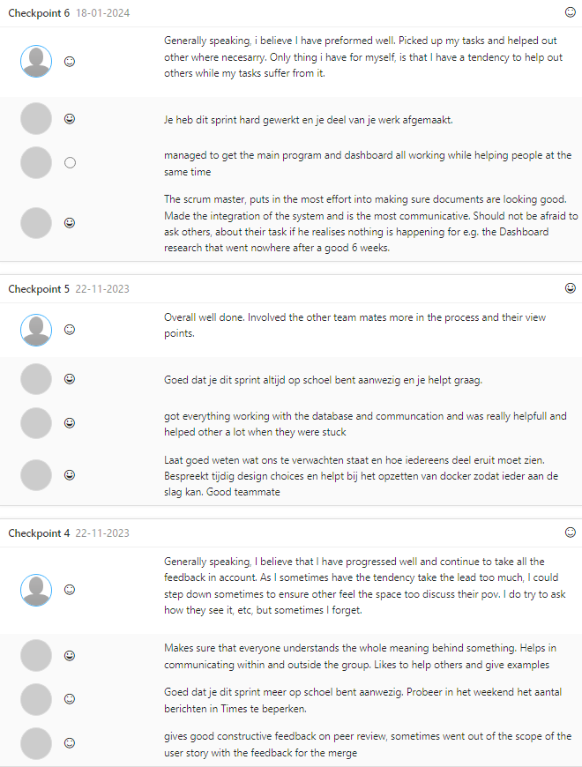
Figure 1. Feedpulse Checkpint 4 - 6
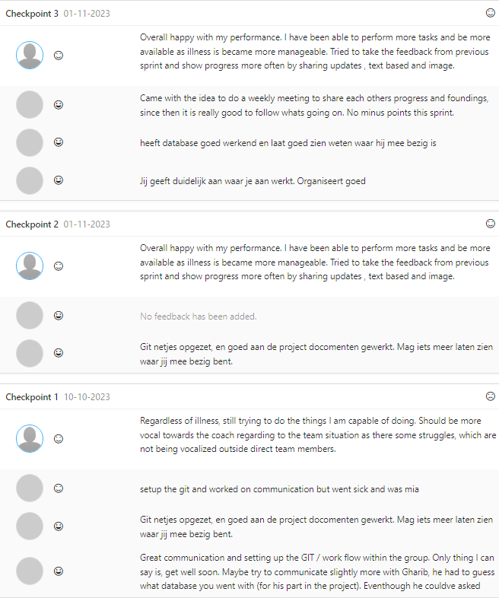
Figure 2. Feedpulse Checkpint 1 - 3

